**Ineos Grenadier – Trailmaster – 1 Owner**

Year - 2023

8-speed automatic transmission with manual overdrive,

BMW 3.0 litre Turbo Petrol straight 6 cylinder engine

Scottish White

* 18” steel wheels, BF Goodrich All-Terrain KO2 Tyre
* Safari Roof
* Bull bar with Integrated 5.5 tonne Winch
* Lockable rear Tyre storage
* Folding Integrated rear door table
* Cargo storage management and quick release tie-down rings x 4
* Tinted windows - 3M Ceramic IR Series side and rear glass, 3M Crystalline Series - Fr window heat reduction

Machine generated alternative text:
GRENADIER 

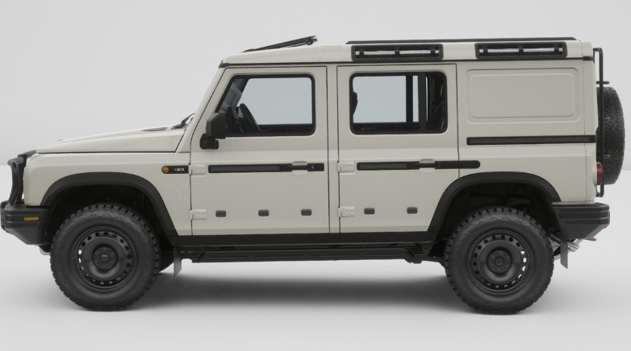

Machine generated alternative text:
GRENADIER 